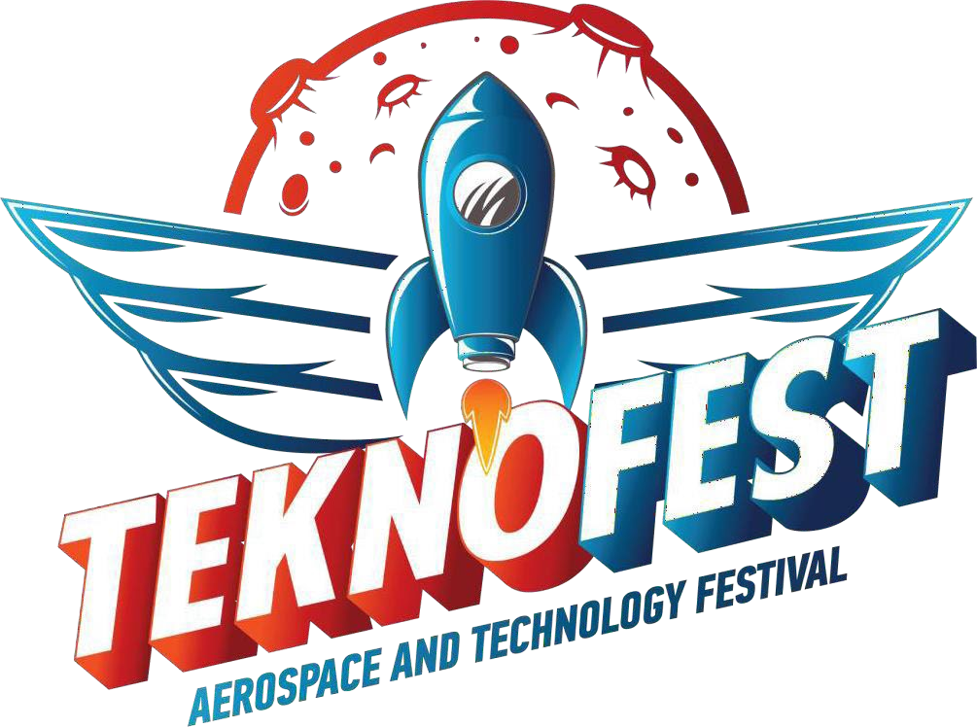

SAILPLANER
(only for citizens of Azerbaijan Republic)
REV.2
1.INTRODUCTION

The competition is aimed at involving young people in aircraft modeling and the development of aircraft designing skills. Participants are invited to an exciting semi-professional competition that includes the assembly of an exact flying copy of the legendary ASW 28 glider, by the installation of avionics, a navigation system, a payload in the form of special cameras and devices for detecting flame points on the ground. This whole process will require the participants to be very accurate of decisions up to every gram, as well as learn how to do an aircraft design, understand tricks of onboard equipment and telemetry, programing and launch an unmanned flight, as well as collect terrain data during flight using various sensors and on-board camera.

2.PURPOSE OF THE COMPETITION

To motivate and develop in young people the ability to conceive, design, Implement and operation of an aircraft from simple to complex, gain real experience in setting up multi-functional aircraft and their programming, dive to background aero modeling. Emphasize creative thinking of possible option in use of this klass of sailpplane in real life by installing a different observation devices.

3.CONTENT OF THE COMPETITION

The competition is aimed at developing the concept and skills in modeling unmanned aerial vehicles based on the all required equipment fully provided by Teknofest Azerbaijan organization comitee and a model of unmanned aerial vehicle (ASW 28 Glider copy or Skywalker X8 plane) as follows:

● Assembling a model of an unmanned aerial vehicle, an exact copy of the ASW28 airframe
● Participants have the ability to choose of an aircraft type,
(There is also a Skywalker X8 model )
● Installation of a standard kit of equipment, main engine ,propeller, flap actuators.
● Determination of the UAV flight plan in the sky according to the mission task specification
● Setting up the required equipment from the kits provided by the organizers
● Installation, launch and programming of on-board equipment and flight controller, avionics and testing
● Installation, programming and launch of payload equipment (arducam) and give video report of in-house simulation flight
● Real flight show up on the flight test site
● Results of the competition at the final of Teknofest Azerbaijan 2022,
Baku Crystal Hall

4.COMPETITION PARTICIPATION CONDITIONS

The competition is open to:
Category A - high school students
Category B – undregraduates/postgraduates, Azerbaijan only
Category C - individual participants and their teams
High school level teams must hire a counselor. The documentstating that the person who will serve as the Consultant will fulfill the consultancy duties must be uploaded to the system together with the Pre-Evaluation Report with wet signature.
- The consultant undertakes to support the team until the last stage and to be with the team at the last stage. In the projects that are at the last stage, it is mandatory that the primary, middle and high school level teams are on the field with their consultants.
- High school level teams will apply through their advisors.
- Participation in the competition can be made individually or as a team.
- Cheating at any phase of the competition is prohibited. Project proposals must be originated from participants. Projects that are found to be similar or imitated will be excluded from the competition. If a participant previously participated in another competition with a similar project, all details of the project in which he/she/they participated (date, place, organizer, result) must be provided to organizers.
- A separate application form must be filled in for each project.
- Teams should be formed with a maximum of 6 members for all categories and education levels. (This number does not include the consultant.) The consultant should not be added as a team member. Each team can have an advisor.
- Transportation and accommodation support for the finalist teams is limited. The number of people to be supported will be notified to the teams later by the T3 Foundation and Teknofest Azerbaijan.
- T3 Foundation and Teknofest Azerbaijan has the authority to limit the number of members to be in the festival area. In case of limitation, information will be given by the committee.
- Only one category or one competition can be applied with the same project. Applications of teams or persons applying to different categories or different contests organized under Teknofest Azerbaijan with the same project will be deemed invalid.
- Members of the same team can apply to competitions organized under Teknofest Azerbaijan with different projects.
- Teams consisting of high school (A) students will compete among themselves, and teams consisting of undergraduates and graduates astudents (B) will compete among themselves.
- Technical support limit is up to 800 USD. Keep in mind that your cost of project shouldn’t be more than 800 USD.
- The contestant will be able to participate in the contest by reading and approving all the explanations about the contest and the participation conditions before applying.
Applicants are deemed to have accepted all of the above conditions.

Application Principles
Applications will be available to fill up on the official website of the Aviation, Space and Technology Festival TEKNOFEST Technology Competitions (www.teknofest.az).
Applicationd deadline is 17.02.2022.

For high school students (Category A):

In the application form;
4.2.1Participant name, surname, high school name, department name and contact information (e-mail address, phone number), information of other group members (student names, department name and contact information), project name and category, and the team name should be added.
4.2.2. Information about the consultant will be taken at the time of application.

For Undergraduates/ Graduates (Category B):

In the application form:
4.3.1.Participant name, surname, university, faculty, department name and contact information (e-mail address, phone number), the team name will be added along with the information of the other group members (student names, university, faculty, department name and contact information), project name and category and the team name should be added
- Information about the consultant will be taken at the time of application.

5.TIMELINE, SCORING AND EVALUATION

Table 1
DATE | DESCRIPTION
17.02.2022 | Competition Application Deadline
28.02.2022 | Anouncemet of the participants passed the registration
18-28.03.2022 | The deadline for distributing to all registered participants a standard kits of all required onboard equipment, including the glider itself. Submission of flight mission specifications
29.04.2022 | The deadline for the submission of in-house flight simulation video report
12.05.2022 | Announcement of the results of the in-house simulation video report. CONCEPT DESIGN REPORT.
16.05.2022 | Real flight show up on the flight test site,mission task
18.05.2022 | Announcement of flight results at the range,  Disclosure of finalists
26-29.05.2022 | TEKNOFEST AZERBAIJAN 2022

Qualifications: The simulated in-house flight will be evaluated through a video report. Participants who have not provided a video report will not be allowed to further participation in the competition.

6.PROJECT INTRODUCTION VIDEO

Teams are obliged to submit their Project Pre-Evaluation Reports and Project Introduction videos on the date specified in the Competition Calendar. In the video, the participants should show the development of the assembly, detailing the components, equipment and their performance, as well as talk about the problems they encountered. The video presentation may be accompanied by a demonstration of tools, equipment, a laptop with the telemetry stream - everything should be in working order .Video must be shared as a You Tube, Vimeo link.

The resolution of the video should be at least 720p, and the total duration should be at least 1.5 minutes and maximum 3 minutes. The video can be taken on a mobile phone.

7.PROJECT DETAIL REPORT CRITERIA

Teams that have passed the previous selection level will be admitted to this level and will be evaluated in accordance to below mentioned:

Readiness of all components:
The functional ready to fly and connection of all details and parts, specified in the specification for the "glider" competition, will be evaluated. The team has the right to write on the wings the name of their team or educational institution, but this must be done carefully and only with acrylic paint, no stickers!

The performance of all components:
- Is the glider ready to fly with all the equipment and payload?
A visual demonstration of the flight simulation process, switching on and off avionics, on-board computer, navigation, sensors and cameras, engine and flips operation. Receiving telemetry to laptop. Simulated collection of data
according to the flight mission specification.

7.2. If you pass the level of the flight simulation video report and get to the next level of real flight show up on the flight test site and mission task:

- Failure of the program or loss of programs or loss of communication with the glider/sailplane or failure in getting of telemetry is not a valid reason for refusing to demonstrate the mission. It is recommended that teams should have a backup copies of softwares on different disks;
- Teams must have as spare fully charged batteries. A discharged battery is not a valid excuse to refuse a project demonstration;
In addition to the above points, the Competition Administration may add another criterion if it deems it appropriate. An update to the criterion will be published in the competition guide

8.COMPETITION SCORING

The scoring of the competition consists of two parts. The first part consists of report scoring, the second part is prototyping and visual presentation scoring.
Report scoring types and percentages are given in the table below. Report scores will constitute 40% of the Total Score.

Table 2: Distribution of the Report

Score Type | Percentage of Score
in-house flight simulation video report | % 40
Real flight show up on the flight test site,mission task | % 60
8.1.Evaluation mission and presentation

The aircrafts of the finalist teams will be judged by teams of an expert jury in their categories. Information about the requirements for competitors showing their gliders on the finals will be published after passing the real flight level at the training base. Teams will print off a promotional poster design for visual presentation and identification of the team. We will provide the poster dimensions at the end of April 2022. The winners among the participants who made it to the final will be announced at the Teknofest Azerbaijan on May 29, 2022 (Baku Crystal Hall)

AWARDS

In qualifying result in three stages in the competition through separate evaluation in its category, the winning team will be awarded in prize money at the final evaluation. The prizes listed in the table below show the total amount to be awarded to the teams that have been awarded prizes, no individual prizes will be awarded. The first, second and third place prizes will be divided into equal amounts according to the total number of Team Members and deposited into the bank account of each person. Payment will be made to the advisor of the winning team within the scope of the competition. A payment up to 700 AZN will be made to the consultants of our ranked teams.

Table 3: AWARDS

Category | A-Category | B - Category | Consultant
1st Place | 5 000 AZN | 5 000 AZN | 500 AZN
2nd Place | 3 000 AZN | 3 000 AZN | 500 AZN
3rd Place | 2 000 AZN | 2 000 AZN | 500 AZN

9.1. Minimum Success Criteria for Award Ranking:

In order to qualify for the prize ranking in the competition, teams must avoid the preliminary elimination. Only those who can qualify for the prize ranking will be eligible to receive the prizes stated in Table 3.

10.GENERAL RULES
- Teams have the right to object to the concerned judge through their team leaders. Objections can be made verbally, provided that they are submitted in writing at a later time. Verbal objections must be put in writing within 24 hours. In any case, non-written objections will not be taken into consideration. Objections will be finalized within 72 hours after having examined by the judge panel.
- After the evaluation results are announced, team leaders are required to submit their objections and justifications in writing. Objections must be received from contest@technofest.az
- The appeal process must be made within one week - 7 days - after the results of the competition are announced. Otherwise, the objections are not taken into consideration.
- The role of the advisor; to help students to plan their own education, to guide them in academic, social and cultural issues, to help prepare the appropriate environment for the development of the student's personality as a whole with its mental, social and emotional aspects, etc. tasks and services. The role of the advisor in the team is to provide the academic support that will be needed in the project, to guide the team members to find solutions to their problems.
- The work of ideas that is the subject of the competition is; may produce with member of the team and this idea belongs to the team and the consultant will not be accepted as the owner of the work.
- Our teams that have benefited from the reports of the past years on our website have to include cited phrase after the sentence cited. CITED FORMAT: "Cited Phrase/s (Year, Competition Name, Category, Team Name) EXAMPLE QUOTE: "Failure to determine the location of the earthquake victim in the wreckage is the most important problem that slows down the debris removal and search for the earthquake victim." (2020, Technology For Humanity, Disaster Management, X Team)
- Each contestant is responsible for taking the necessary precautions and showing the expected attention to his/her peers and the environment.
- T3 Foundation and the Teknofest reserve the right to make any amendments to the specifications in order for the contest to take place in accordance with the specified impartial criteria so that any violations may result in judicial outcomes, to better meet all sorts of requirements by the contestants, to provide necessary safety precautions and to maintain the functionality of the contest specifications.
- Having made the necessary evaluations following the application deadline, T3 Foundation and the Teknofest Azerbaijan reserves the right to cancel the contest given that sufficient number of applications is not reached with the required technical knowledge and skills.

- T3 Foundation anad Teknofest Azerbaijan Safety and Security Terms and Conditions will be communicated to all contestants, delegations and concerned parties. All competing teams are responsible for observing the safety terms and conditions specific to their respective categories specified in Teknofest Azerbaijan Safety and Security Terms and Conditions. In this regard, with the exception of security precautions contained in the aforementioned security instructions, it is the contestants’ responsibility to take additional precautions arising from the systems employed.
- T3 Foundation and the Teknofest Azerbaijan as the right to exclude any and all teams from the contest who do not fulfill the terms and conditions of Teknofest Azerbaijan Safety and Security Terms and Conditions to provide a safe environment for holding the contest. T3 Foundation and organisation officials cannot be held responsible for damages arising from the violation of terms and conditions by the contestants, delegations and concerned parties.
- Regarding the competition, the competitor hereby accepts and consents to any kind of written or visual promotion, publication, social media and internet broadcasting to be made by the T3 Foundation and / or Teknofest Azerbaijan before or after the competition. In addition, the competitor agrees and submits that any and all intellectual property generated as pertains to the competition, including but not exclusive to designs, code, and manufactured products, belongs exclusively to the T3 Foundation and / or Teknofest Azerbaijan and that the competitor does not have any rights to or demands on these artifacts. T3 Foundation and Teknofest Azerbaijan reserves the right to disclose all intellectual property thereby for public consumption in a manner it deems fitting.
- In the event that a competitor infringes upon the intellectual property rights of any product, and T3 Foundation and/or Teknofest Azerbaijan Production Office incur damages, the responsibility for such damages will be borne entirely by the relevant participant(s).
- All teams who qualify to compete in the contest will be given a Participation Certificate.

11.ETHICAL RULES

- The legal process will be urgently initiating for the people who performs a situation, action, speech, etc. contrary to social morality in the festival area or during the competition process (report stages, evaluation process, etc.) And team will be banned from all kinds of events and activities of T3 Foundation to participate at least 2 years.
- The issues to be considered in the language used in all communication with the T3 Foundation and Teknofest Azerbaijan are as follows:
- Rude and impolite words and behaviors must be avoided,
- Insults, threats and bad words must be avoided,
- Direct targeting and insulting with social media tools such as E-mail, facebook, skype, messenger, whatsapp, twitter etc. must be avoided,
It is necessary to pay attention to the spelling rules and style in your petitions and objections.
- Situations, verbs, words etc. that will affect the functioning and motivation of other teams in the festival area must not be exhibited.
- Social peace in the dormitory and its surroundings where accommodation services are provided should be taken into consideration. Otherwise, the initiation of the legal process against the person will be carried out by the relevant institutions.
- During the project and product development process, it is the responsibility of the team to back up / store the necessary equipment and materials in advance, taking into account all kinds of negativity, and to change parts in case of a possible negativity. Product supply from another team must not be provided.
- Care should be taken to act in accordance with the service requirements in neutrality, without discrimination of language, religion, philosophical belief, political opinion, race, age and gender, and without giving rise to behaviors and practices that prevent equal opportunity in the festival area and in all kinds of services offered by T3 Foundation and Teknofest Azerbaijan.
- It is necessary to pay attention not to use and use T3 Foundation, Teknofest Azerbaijan and other company, institution, organization goods and resources outside of their purposes and service requirements, and not to waste these goods and resources.
- It is necessary to support the activities carried out in order to facilitate the functioning of the festival, to meet its needs in the most effective, fast and efficient way, to increase the quality of service and to increase festival satisfaction.
- Be careful about all kinds of benefits and financial or other liabilities and similar personal interests provided to themselves, their relatives, friends or the persons ororganizations with whom they are in contact and that affect or seem to affect the competitors in the festival area to perform their duties impartially and objectively, to act and take the necessary precautions to avoid conflicts of interest.

- When using T3 Foundation and Teknofest Azerbaijan buildings and vehicles and other public goods and resources, it is necessary to avoid waste, to act effectively, efficiently and economically while using working time, public goods, resources, labor and facilities.
- T3 Foundation and Teknofest Azerbaijan team members must be accountable for their responsibilities and obligations during their execution, and are open and ready for corporate evaluation and supervision, advisors should take the necessary measures to prevent corruption with the actions or actions that are not in line with the goals and policies of their institutions, and train their members on ethical principles of behavior, It should be monitored whether these principles are followed or not and provide guidance on ethical behavior.
- While fulfilling their duties, team members should not make any commitments, promises or attempts binding the institutions they work for, and should not make deceptive and untrue statements.

12.STATEMENT OF LIABILITY

Turkish Technology Team Foundation and Ministry of Digital Development and Transport of the Republic of Azerbaijan are in no way liable for any injury or damage caused by any entry, any entrant, or by the disqualification of an entry. Turkish Technology Team Foundation and Ministry of Digital Development and Transport of the Republic of Azerbaijan at large are not responsiblefor ensuring teams operate their systems within the law of the Azerbaijan Republic. The Turkish Technology Team Foundation and Ministry of Digital Development and Transport of the Republic of Azerbaijan, and organisation officials cannot be held responsible for the damages inflicted upon third parties by the contestants.

Turkish Technology Team Foundation and Ministry of Digital Development and Transport of the Republic of Azerbaijan has the right to make any updates to this terms and conditions.

